電通二乙微處理器實驗 實驗結報

實驗名稱 | Lab 01 – LED Blink
組別 | 33 | 組員 | 呂睿中/楊適名

- 實驗目的
使用 circuits.io 模擬 Arduino UNO 電路及程式
觀察 Arduino UNO 之輸出

- 實驗步驟
註冊circuits.io帳號，啟動 Arduino 模擬器。
接上 LED 電路及100歐姆電阻。
觀察 LED 之閃爍間隔，修改程式, 讓LED 閃爍間隔分別增加為兩倍及一半 , 重新量測然後截圖。

- 程式碼

初始程式碼:
// the setup function runs once when you press reset or power the board
void setup() {
// initialize digital pin 13 as an output.
pinMode(13, OUTPUT);
}

// the loop function runs over and over again forever
void loop() {
digitalWrite(13, HIGH); // turn the LED on (HIGH is the voltage level)
delay(1000); // wait for a second
digitalWrite(13, LOW); // turn the LED off by making the voltage LOW
delay(1000); // wait for a second
}

兩倍程式碼:
// the setup function runs once when you press reset or power the board
void setup() {
// initialize digital pin 13 as an output.
pinMode(13, OUTPUT);
}

// the loop function runs over and over again forever
void loop() {
digitalWrite(13, HIGH); // turn the LED on (HIGH is the voltage level)
delay(2000); // wait for a second
digitalWrite(13, LOW); // turn the LED off by making the voltage LOW
delay(2000); // wait for a second
}
一半程式碼:
// the setup function runs once when you press reset or power the board
void setup() {
// initialize digital pin 13 as an output.
pinMode(13, OUTPUT);
}

// the loop function runs over and over again forever
void loop() {
digitalWrite(13, HIGH); // turn the LED on (HIGH is the voltage level)
delay(500); // wait for a second
digitalWrite(13, LOW); // turn the LED off by making the voltage LOW
delay(500); // wait for a second
}

- 實驗結果及分析
更改delay值後，發現燈泡閃爍會因delay值大小不一而快慢不同。
2000閃爍變慢，500閃爍變快

- 心得討論

電路圖好玩
Arduino好玩，線上接電路圖比較方便
Github上傳也好玩，可以直接線上更改成是更加方便

對arduino有初步的了解!
- 修正電路圖
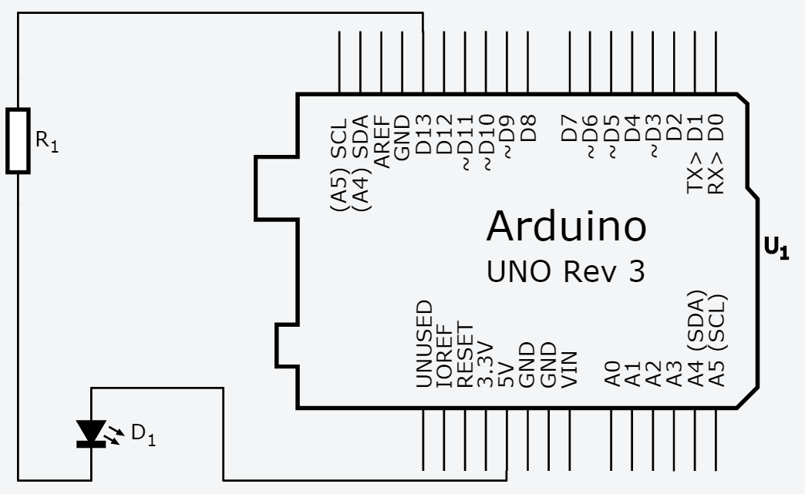
- 修正程式碼

